**DAY -25 TASK**

**TASK:**

TASK FIVE: HIGHER ORDER FUNCTIONS, GENERATORS, LIST COMPREHENSION AND DECORATOR

1. Write a program to Python find the values which is not divisible 3 but is should be a multiple of 7. Make sure to use only higher order function.

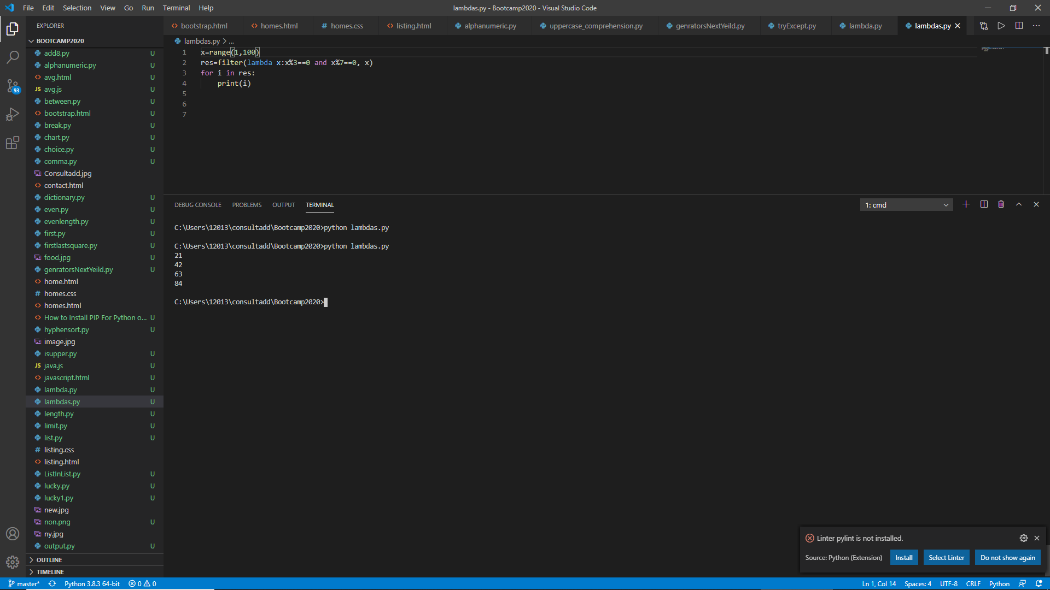

2. Write a program in Python to multiple the element of list by itself using a traditional function and pass the function to map to complete the operation.

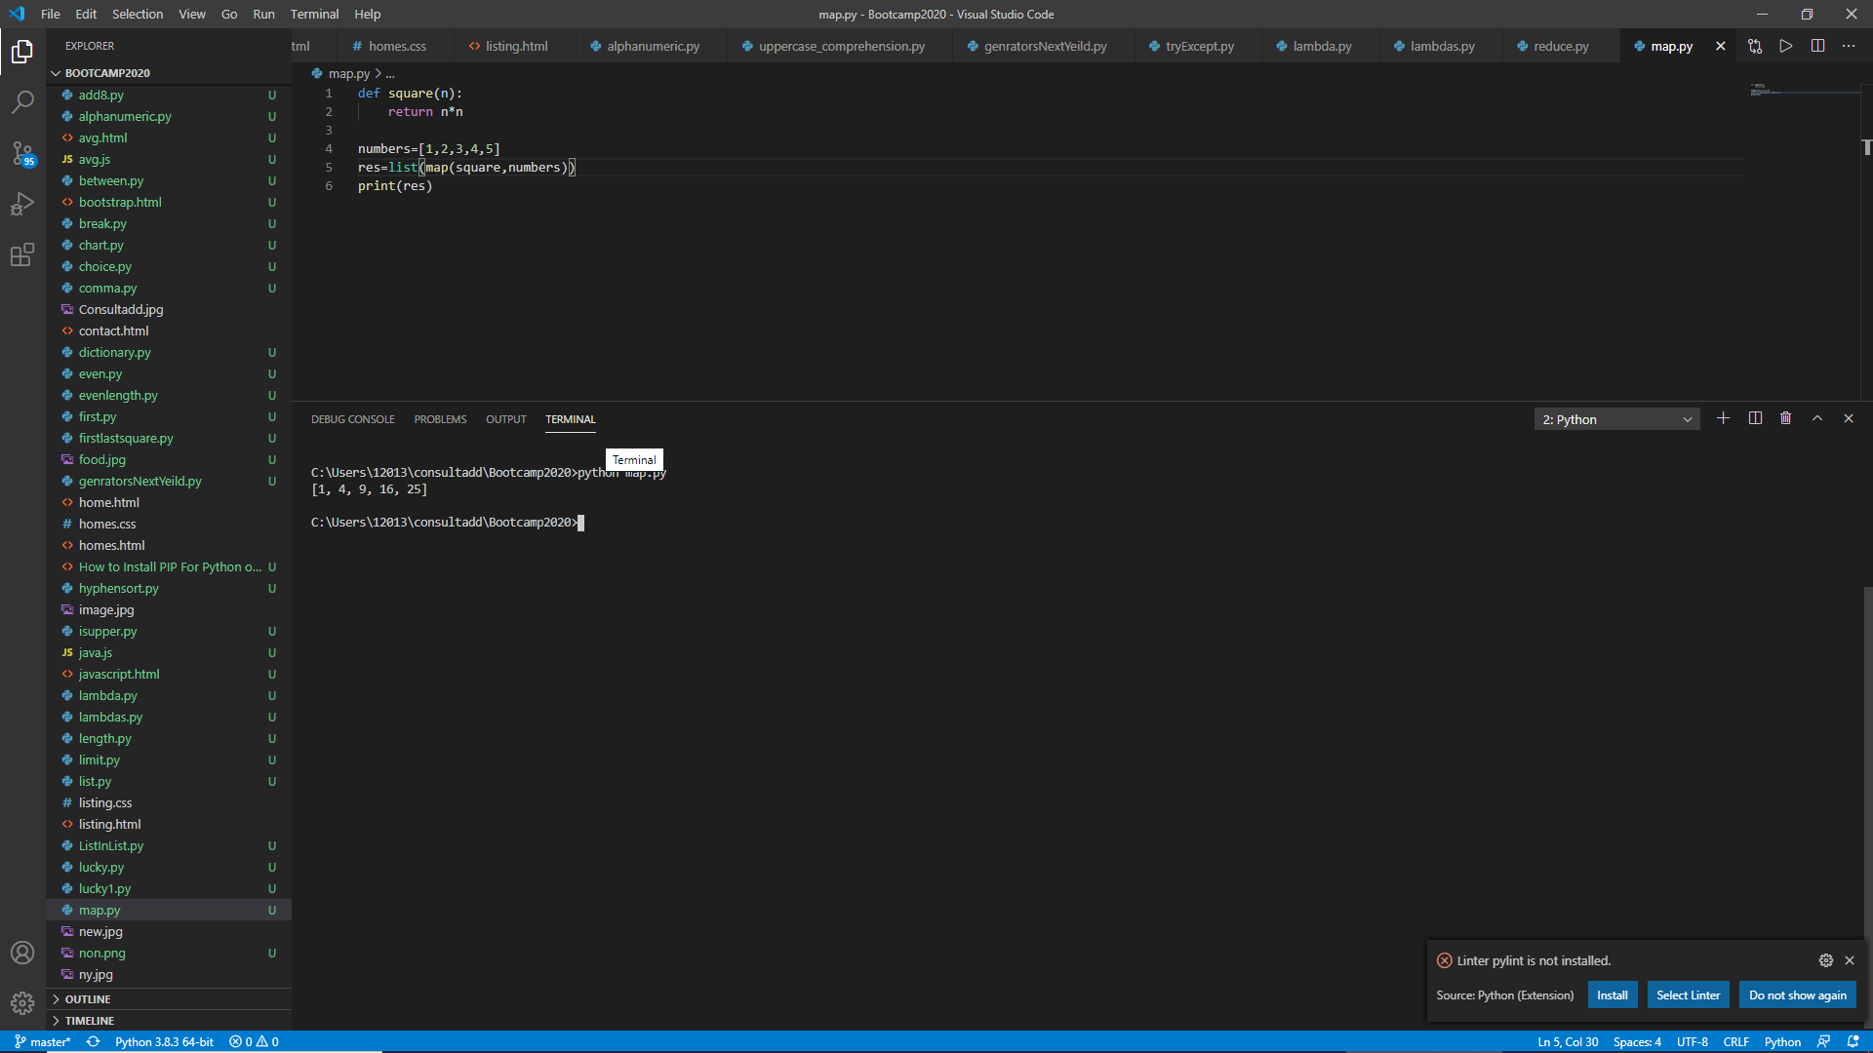

3. Write a program to Python find out the character in a string which is uppercase using list comprehension.

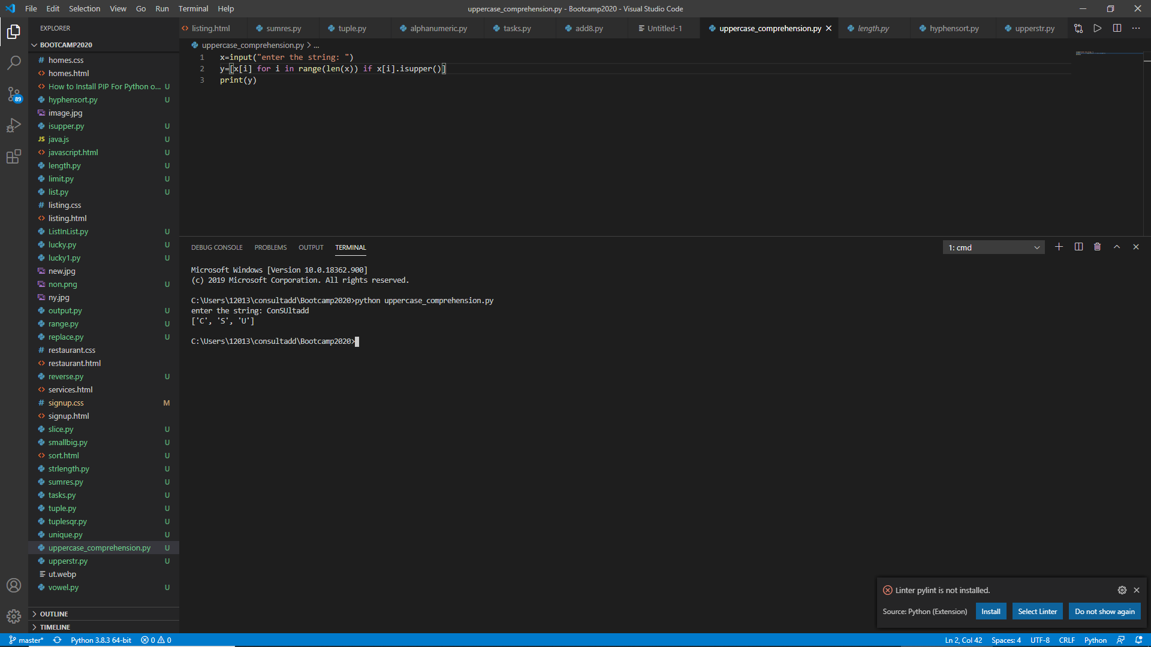

4. Write a program to construct a dictionary from the two lists containing the names of students and their corresponding subjects. The dictionary should maps the students with their respective subjects. Let’s see how to do this using for loops and dictionary comprehension. HINT-Use Zip function also

● Student = [&#39;Smit&#39;, &#39;Jaya&#39;, &#39;Rayyan&#39;]

● capital = [&#39;CSE&#39;, &#39;Networking&#39;, &#39;Operating System&#39;]

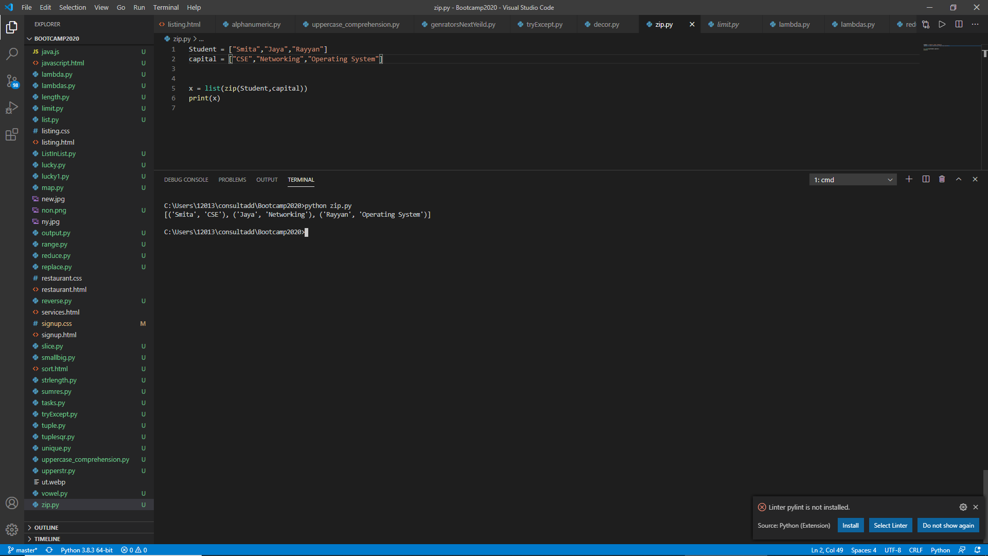

5. Learn More about Yield, next and Generators

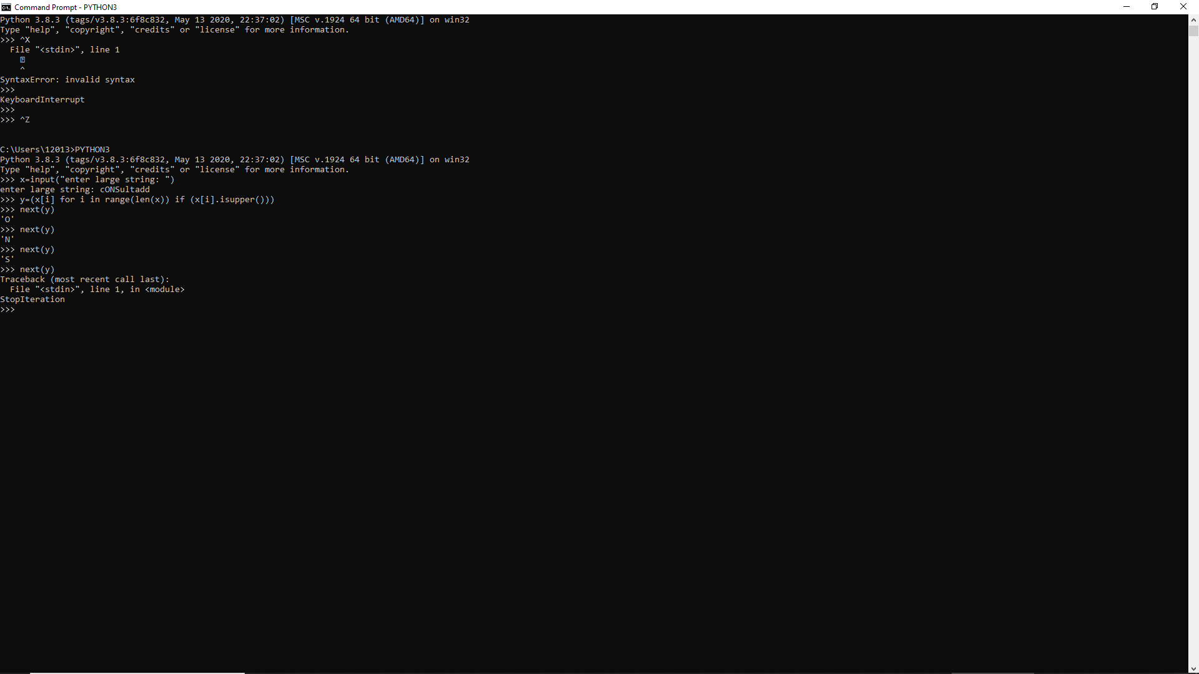

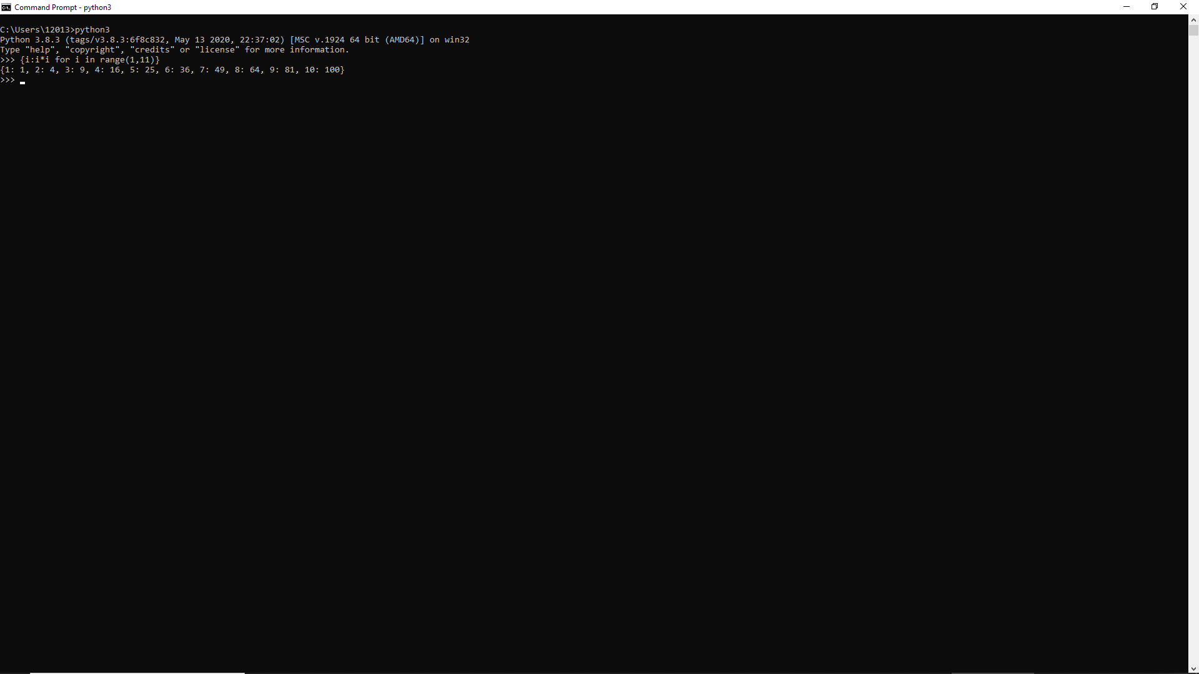

Yield:

It is something that returns data one by one instead of returning it in the form of a big chunk. It is like a function but when you call a function instead of getting the entire function executed it gets executed partially on each Next() call.

def my_gen():

n = 1

print('This is printed first')

# Generator function contains yield statements

yield n

n += 1

print('This is printed second')

yield n

n += 1

print('This is printed at last')

yield n

Suppose above is the function and we call it

By a=my_gen()

Now instead of showing entire output it will wait for next to be called

next(a)

Now it will be executed till first “Yield” and stop and it you type “next(a)” again then again it will start executing it self from first “yield” and go till next “yeild”

6. Write a program in Python using generators to reverse the string. Input String = “Consultadd Training”

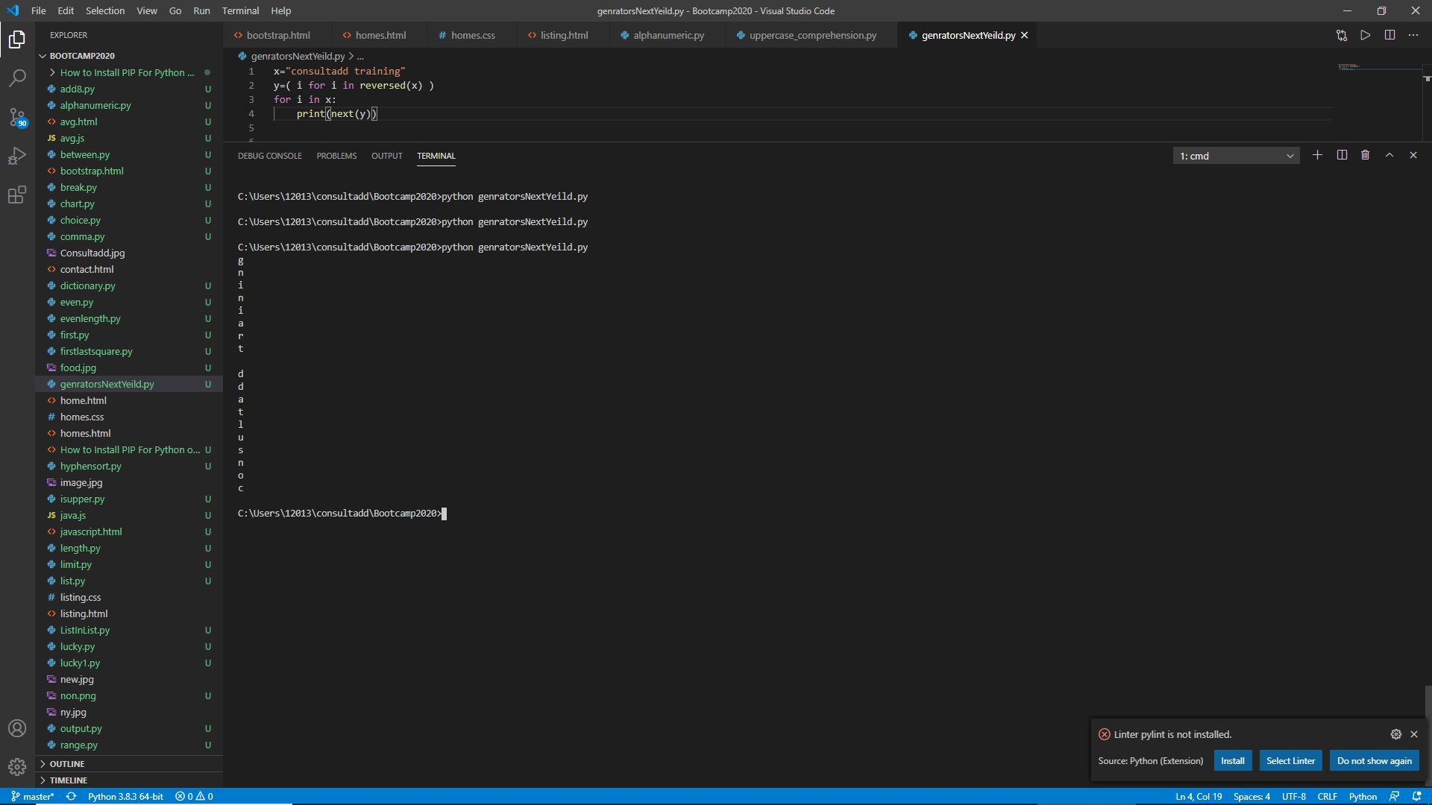

7. Write any example on decorators.

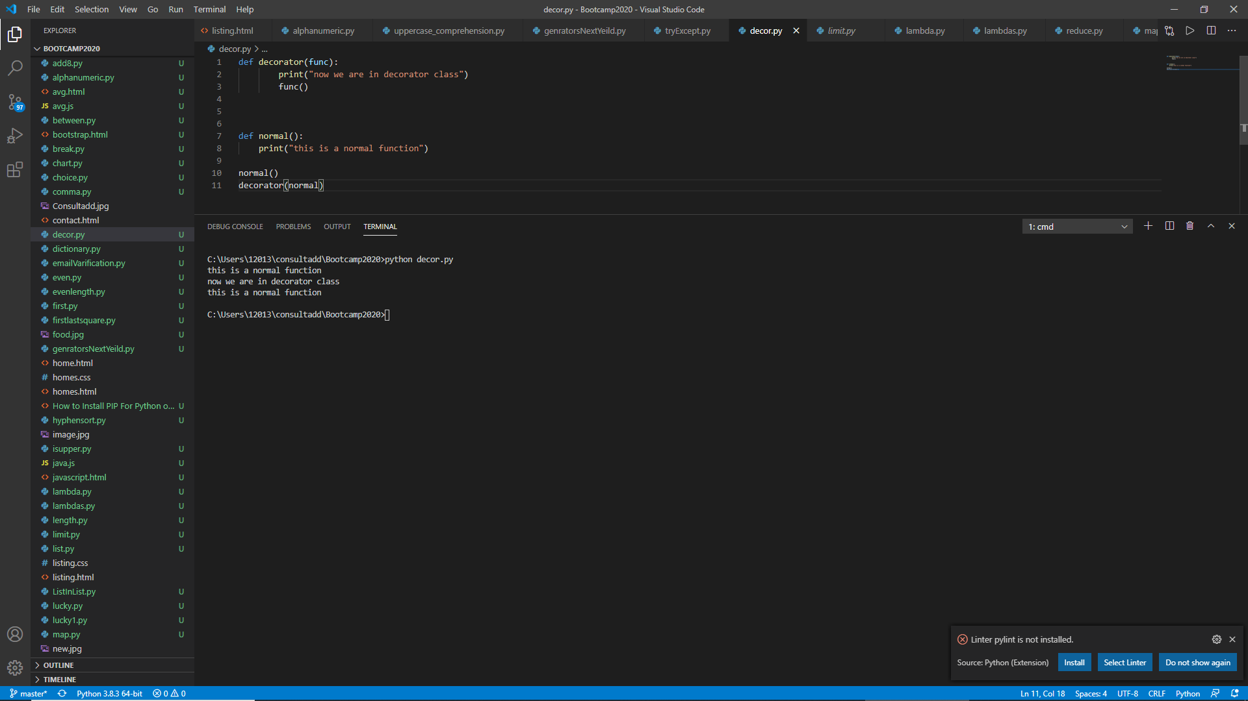

8. Write a program to handle an error if the user entered the number more than

four digits it should return “Please length is too short/long !!! Please provide only four

Digits”

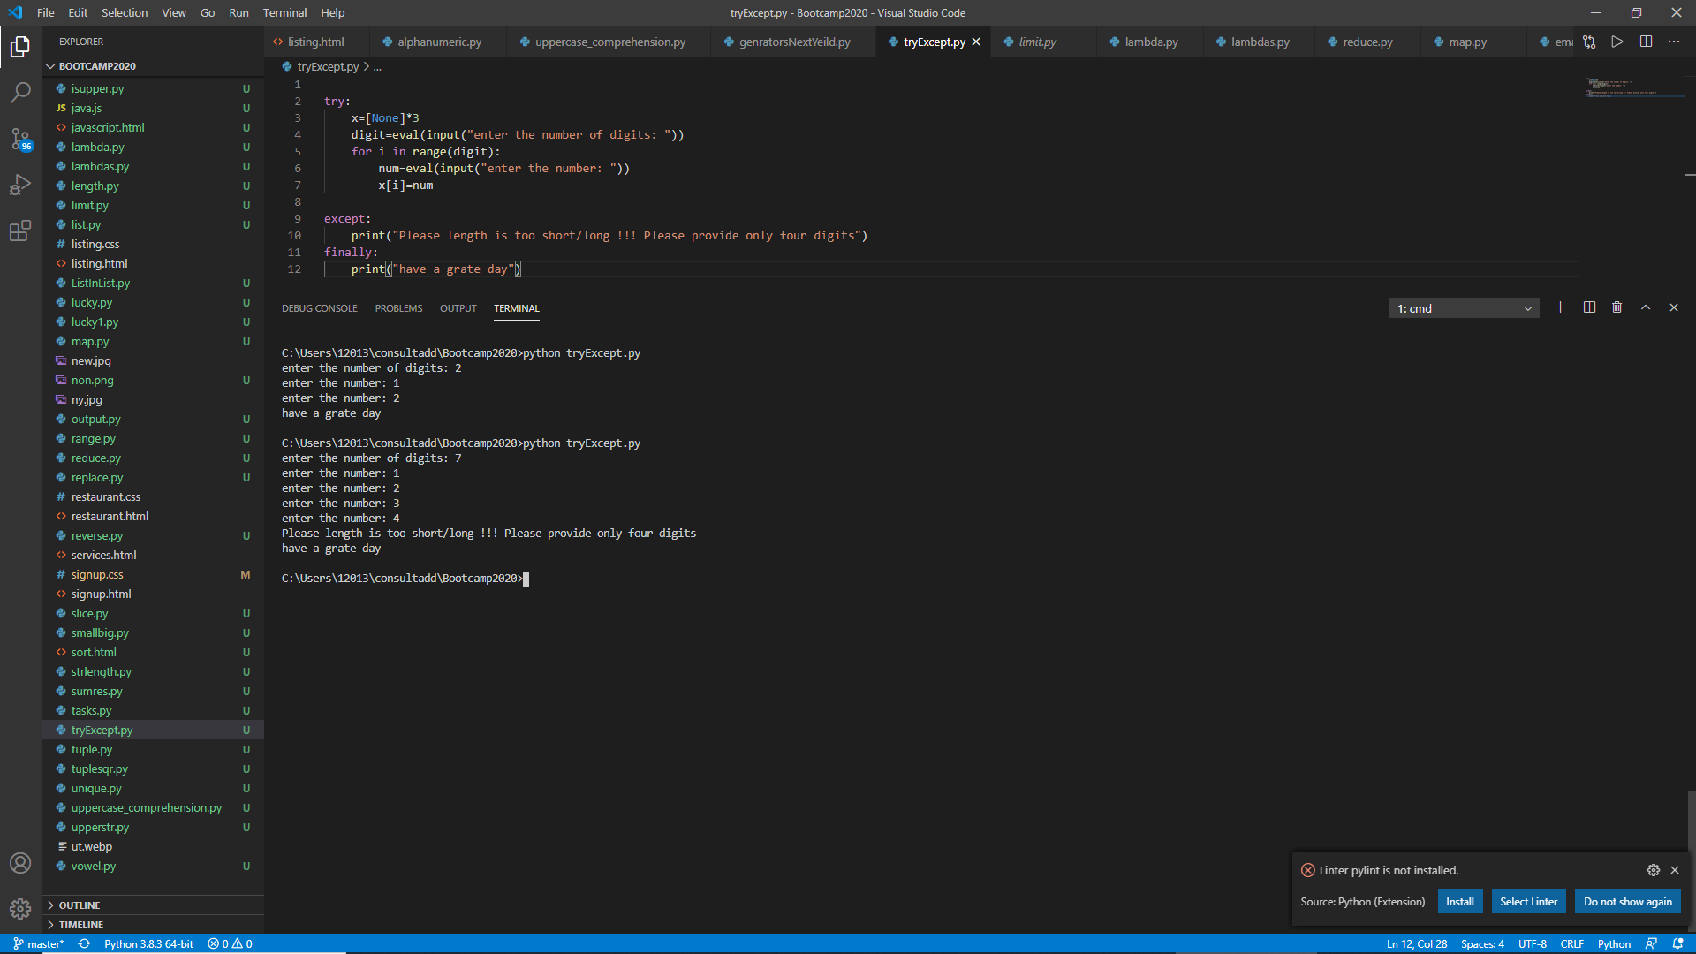

9. Create a login page backend to ask user to enter the UserEmail and password.

Make sure to ask Re-Type Password and if the password is incorrect give chance to

enter it again but it should not be more than 3 times.

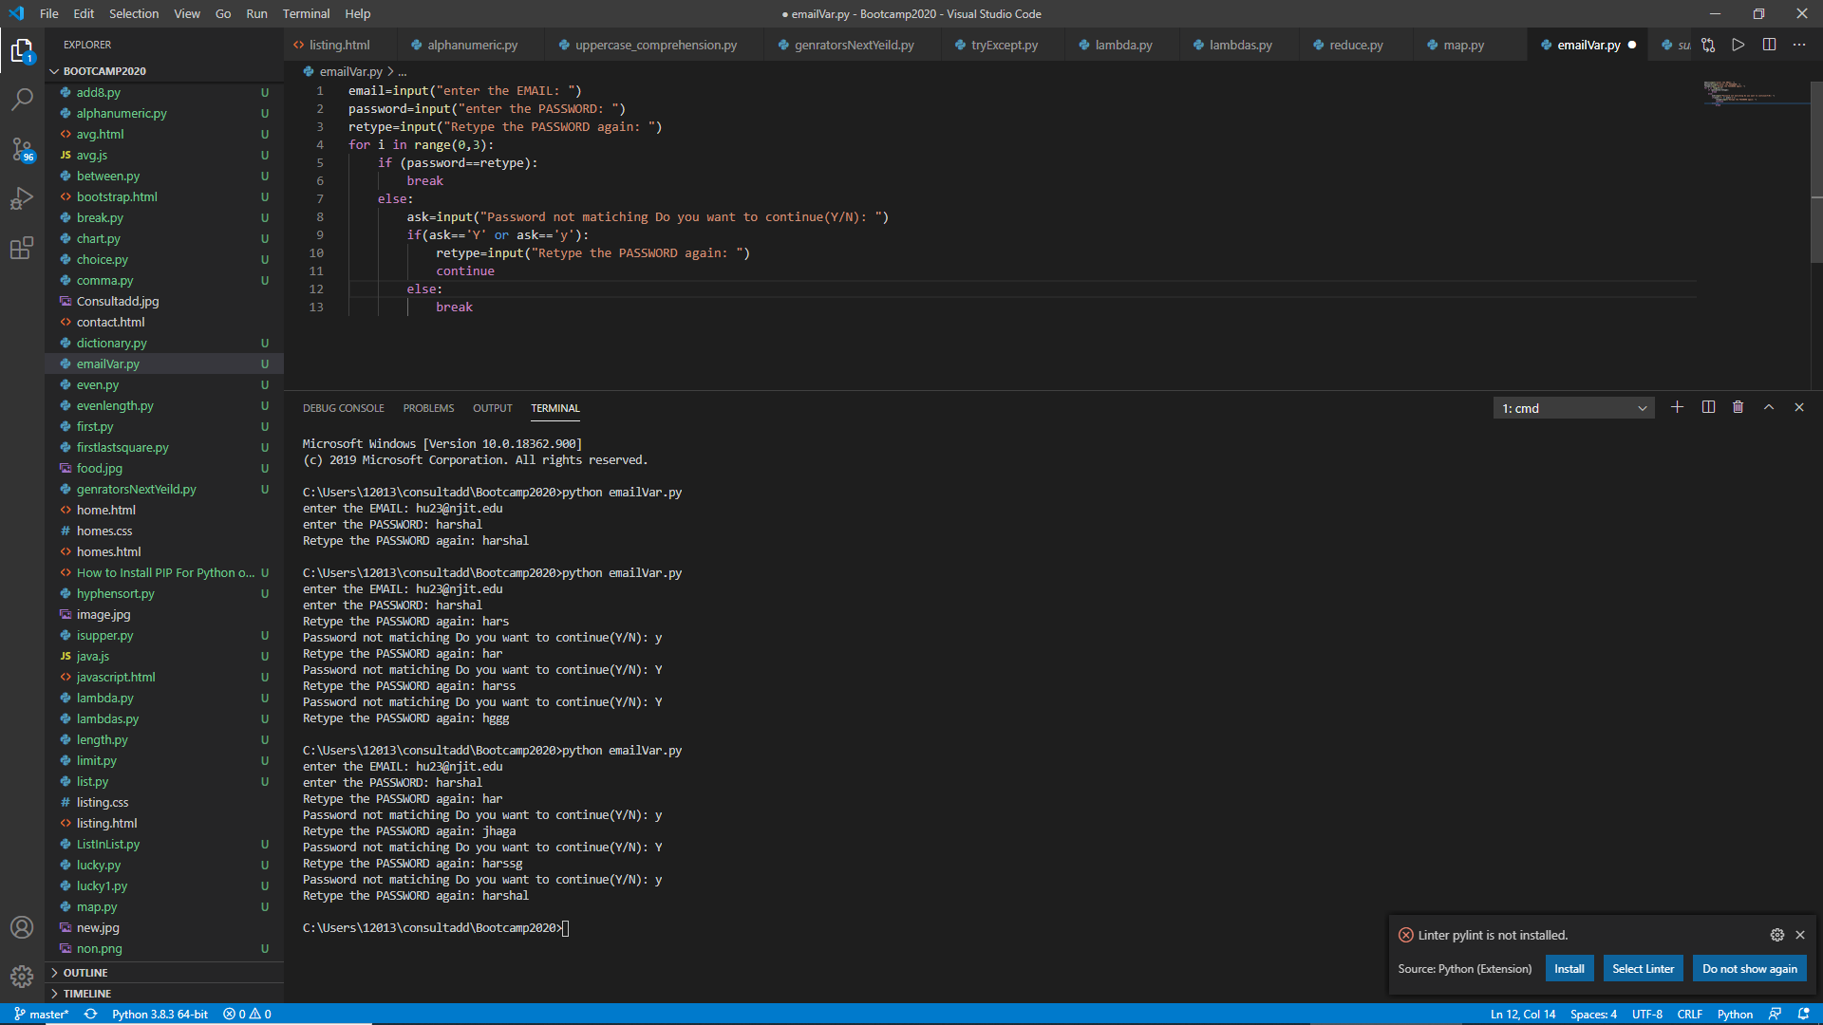

10. <https://www.programiz.com/python-programming/exception-handling> Go

through this link to understand Finally and Raise concept.

